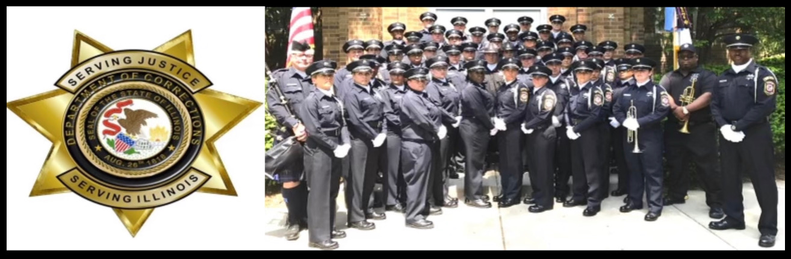

Work for the Illinois Department of

CORRECTIONS

Apply first at [www.Illinois.gov/idoc](https://www2.illinois.gov/idoc/aboutus/Pages/Careers_At_IDOC.aspx) then attend a screening at:

**East STL Higher Educational Center**

**601 J.R. Thompson Blvd. East St. Louis, IL 62201**

**When:** Wednesday, June 8, 2022

Correctional Officer Trainee/Correctional Treatment Officer Trainee

**Time:** Sign In begins at 7:30 AM

*Please plan to be at the screening venue until at least 3:00pm.*

Contact Central Screening Office for invitation and paperwork.

217-558-4127

**Applicants must be a US citizen or national of the United States, a permanent U.S. resident or a registered alien who is authorized to work in the United States, who is at least 18 years old with a High School Diploma or GED and a valid driver’s license.**

**Salary Ranges:**

**COT/CO $45,708 – $68,580 and CTOT/CTO $52,572 – $85,236 annually.**

*\*The IDOC is an Affirmative Action and Equal Opportunity employer with a strong commitment to diversity. In that spirit, they are particularly interested in receiving applications from a broad spectrum of people, including, but not limited to, minorities, women, veterans, and individuals with disabilities.*