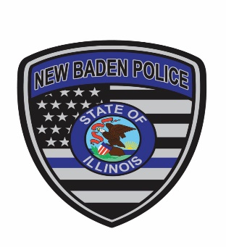

New Baden Police Department

100 East Hanover

New Baden, IL. 62265

Non-Emergency 618-588-7741

Emergency Dial 911

Charles Mackin Clinton and St. Clair Counties

Chief of Police Since 1855

**Open Position: Police Officer**

Starting salary: $24.47 per hour 2184 hours per year for a base salary of $53,442

* Union Position with the PBPA Collective Bargaining Agreement (CBA)
* Officer primarily works night and/or evening shifts, weekends and holidays. Schedule is subject to change and modification as per department needs.
* Longevity wage increases as per the CBA.
* Benefits include: Employer pays 90% medical insurance including vision and dental for employee and dependents; life insurance; IMRF, vacation, sick leave and paid overtime per CBA.

**Job Requirements**

* US citizenship
* Applicants must between 21 and 35 years of age with or without prior Law Enforcement experience. A military veteran or experienced Police Officer shall be allowed to exceed the maximum age provision by the nearest whole number of years served.
* High school diploma or equivalent
* Valid Illinois Driver’s License
* Candidate must have completed Full-time Police Academy or Part-time Police Academy. Applicants who previously attended Part-time Police Academy require previous active road experience. Successful completion of the ILETSB 80-hour transition course is required within the 12-month probationary period.
* No felony convictions or other criminal convictions preventing ILETSB certification
* Successful completion of:
* Psychological
* Polygraph
* Physical, Fit for Duty
* Drug and Alcohol Screen
* Background Check

Within the 12-month probationary period, the officer must complete in-house field training and meet residency requirements of set forth in the PBPA Collective Bargaining Agreement (CBA).