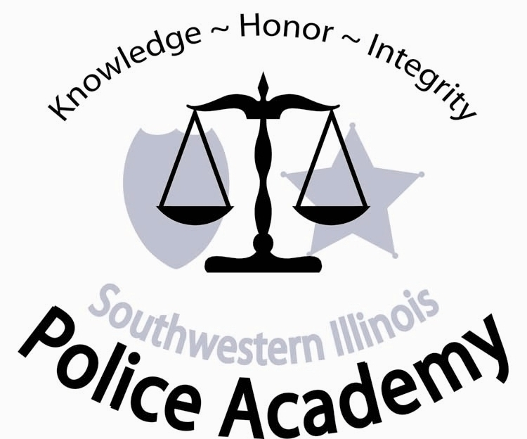
Police Academy
2500 Carlyle Avenue • Belleville, IL 62221-5899
800-222-5131, ext. 5396 • (618) 235-2700, ext. 5396 • Fax (618) 236-1094
E-mail: Van.Muschler@swic.edu

Dear Deputy or Officer:

POWER Test and Orientation

Saturday, August 28,2021, 8:00AM has been scheduled for the Peace Officer Wellness Evaluation Report (POWER) Test and Orientation. Recruits must pass the POWER Test in order to attend the Academy.

1. Recruits must be in Room 1515 before 8:00AM.
2. Firearms will not be carried or brought on campus unless requested or permitted by the academy staff or the range master.

The POWER Test will be administered at 8:00AM sharp. Recruits who do not have a completed medical form on file, (this is the physical fitness exam form) or with them the morning of the testing CAN NOT be tested and WILL NOT be admitted to the academy. No one will be admitted to the Academy that fails to arrive on time for this test. Clothing for the POWER Test (locker room facilities will be available):

1. Short sleeve, athletic T-shirt.
2. Athletic shorts (must have on during "sit and reach" exercise, knees must be clearly visible).
3. Hooded sweatshirt and sweatpants (if necessary) or other clothing as weather dictates, RECRUITS SHOULD PLAN ON RUNNING OUTSIDE.
4. Athletic socks.
5. Running shoes.

DRESS CODE FOR THE POLICE ACADEMY

1. After POWER Test change into department issued uniform shirt, long or short sleeve, with collar, buttoned down the front. If a uniform is not available, recruits should wear a long sleeve dress shirt, with collar, buttoning all the way down the front and tie.

2. The following dress code will be adhered to throughout the training session:
Police Academy Uniform:

Police Academy Uniform:
  - Grey Police Academy BLE Polo – Two (2) provided by the Police Academy.
  - Black 5.11 Tactical Pant (Mfg. #74251) or Black 5.11 Taclite Pro Pant (Mfg. #74273) – Two (2) recommended provided by department or student.
  - Department issued shoes or boots; black.

PARKING

Parking is available on the south side of the campus in parking lot M5. You should park in the PARKING LANE FACING SIDEWALK DIVIDER BETWEEN LOT M5 and M4. See attached Belleville Campus Map.

I am looking forward to meeting you. If you have any questions please call the Academy office (618) 235-2700, extension 5396.

Sincerely,

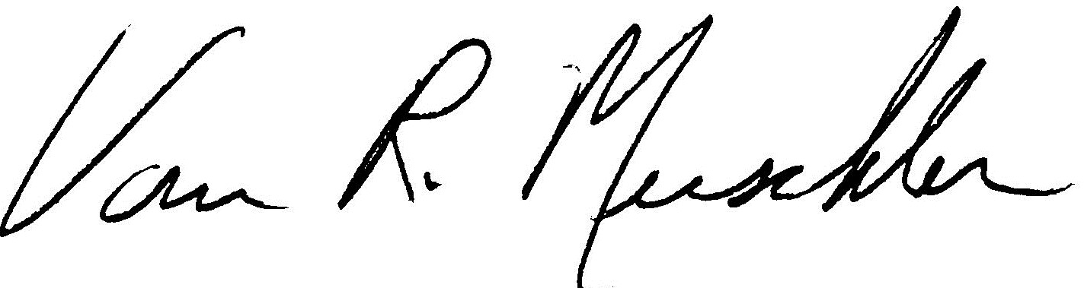

Van Muschler, Director
Southwestern Illinois Police Academy

SPECIAL NOTE: Any missed class sessions or part thereof, as a result of illness or injury will result in the recruit being docked the time missed and will be listed as hours absent. An officer will be considered absent even if present, when he/she is unable to perform or participate in the classes scheduled activities. Absences in excess of 56 hours will result in dismissal from the academy.
ITEMS TO BE SUPPLIED BY OFFICERS/AND/OR DEPARTMENT DURING THE BASIC TRAINING PROGRAM.

1. 5.11 Tactical Pants, black. Two (2) recommended.
2. Duty Belt
3. Duty Weapon Holster
4. Duty belt magazine case
7. Duty belt handcuff case and handcuffs (with key)
9. One police style flashlight for night training exercises
10. Pocket size notebook
11. Department squad car if possible should be provided for defensive driving and traffic stop procedures. (Recruits will be notified of the exact dates when they receive their schedule)
12. Electronic or hard copies of the following forms should be sent with the recruit officer.
A. Photo or electronic copy of department's Notice to Appear form.
B. 60 photocopies or electronic copy of department’s traffic citations.
C. 5 photocopies or electronic copy of department’s misdemeanor complaint form.
D. 1 photocopy or electronic copy of department written Miranda form.
E. 1 photocopy or electronic copy of department’s field sobriety report form.
F. 1 photocopy or electronic copy of department’s domestic violence report.

(Your department may not utilize all of the above-mentioned reports and forms. Bring with you the reports and forms your department does use.)

