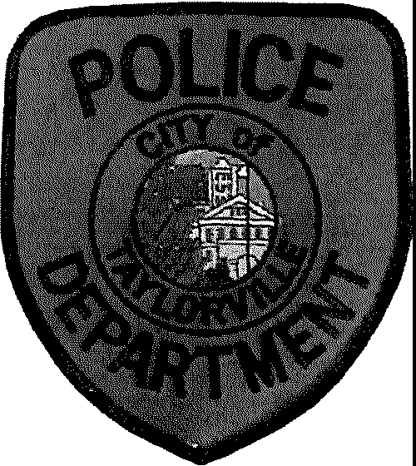The City of Taylorville Police and Fire Commission will be holding an examination for the position of Entry Level Police Officers. Testing is being conducted to establish an eligibility list.

# **"Testing Date:** December 14th, 2024 at 10 A.M. at Taylorville Fire Department.

Orientation, P.O.W.E.R. Test, and Written Examination. **Written test can be completed online prior to by registering at

Nationaltestingnetwork.com.

**You must register online prior to orientation to test at TFD.

**Qualifications Starting Pay $64,864**

* Must be a U.S. Citizen or an individual who has permanent resident status and is Legally authorized to work in the U.S.
* Possess a Valid Driver's License

• Must be 21 years of age at the time of application. Must be under 35 years of age at the time application, unless you have been certified as a police officer or are otherwise exempt by IL state statute 65 ILCS 5/10-2.1-6

* Possess a High School Diploma or equivalent
* Possess valid FOID Card
* Must have no felony convictions and certain misdemeanors and be of good moral character 65 ILCS 5/10-2.1-6

Benefits

* 20 Mile Residency
* All required uniform items provided
* Uniform Allowance
* Paid Vacation Days
* 12 hour Shifts
* Illinois Pension Fund

**Applications**

* Special Assignments (SRO/Detective/K9)
* Emergency Response Team
* CAT Team (Drug Team)
* Life Insurance
* Additional Benefits discusses at orientation

Applications are available on our website or can be picked up at the Taylorville Police Department

 <https://taylorville.net/police-dept/>

***\*\*Must bring ID and completed application at time of testing.\*\****